
School of Computer Engineering
KIIT Deemed to be University
Java Programming Laboratory Lesson Plan
Spring 2024-25 (4th Semester)

Discipline : CSE
Course name and Code : Java Programming Laboratory (CS29004)
L-T-P-Cr : 0-0-2-1
Instructor Name : Dr. Rajat Kumar Behera
Email: rajatkumar.beherafcs@kiit.ac.in
Contact No: 9886072882

Instructor Chamber : Cubicle- E, Faculty Block -105, Block-B, Campus-15
Technical Assistants Names:
TA-1(Mr. Pradyumna Kumar Sahoo, pradyumna.sahoo@kiit.ac.in, 9438389003)
TA-2 (Mr. Prasanta Kumar Panda, prasant.panda@kiit.ac.in, 9861275798)
Course Outcomes:
Upon completion of this course, the students will be able to:
CO1: Run java programs using java compiler/IDE
CO2: Write java programs using basic object oriented programming concepts
CO3: Write programs using abstract classes interfaces and packages
CO4: Write java program using multi-threading and exception handling
CO5: Design Java application using String and I/O classes
CO6: Design GUI application using Swing and interactive application using event handling and JDBC
List of Experiments (Day wise):
Writing, compiling and executing Java programs

Lab 1: Course Contents: - Writing, compiling and executing a simple Java programs

- Aim of the program – Write a program to print your name, roll no, section and branch in separate lines.
Input: Mention Name, Roll no, Section and branch
Output: Display Name
Display Roll No
Display Section
Display Branch

- Aim of the program: Write a program to print the corresponding grade for the given mark using if..else statement in Java
Input: Mention the mark
Output: Display the Grade either O/E/A/B/C

- Aim of the program: Write a program to print the week day for the given day no. of the current month using switch case statement
Input: Mention the Day no in the program
Output: Display the week day (either Sunday/Monday/Tuesday/Wednesday /Thursday/Friday/Saturday)

- Aim of the program: Write a program to check a user entered number is palindrome or not
Input: Mention the number in the program
Output: display the number is Palindrome or not.

- Aim of the program: Write a program in Java to take first name and last name from user and print both in one line as last name followed by first name
Input: Enter first name: KIIT
Enter Second Name: UNIVERSITY
Output: UNIVERSITY KIIT

Lab 2 - Course Contents: - Array in Java
- Command line arguments in Java, Scanner Class
- Static modifier in Java
- Aim of the program : Find the largest among 3 user entered nos. at the command prompt using Java
Input: Enter three numbers.
Output: Display the Largest Number

- Aim of the program: Accept 10 numbers from command line and check how many of them are even and how many are odd.
Input: Enter 10 number from keyboard
Output: Display number of even and odd number

- Aim of the program: Program to sort the user entered list of numbers of any size
Input: List of Numbers
Output: Display the numbers in ascending order

- Aim of the program: Program to find no. of objects created out of a class using ‘static’ modifier.
Input: No of objects created
Output: Display the number of objects created (e.g. no of objects=3)

- Aim of the program: Find the no. of occurrence of each element in a user entered list of nos.
Input: Enter list of numbers e.g. (15 25 15 11 25 32 15 32)
Output: Occurrence of 15=3
Occurrence of 25=2
Occurrence of 11=1
Occurrence of 32=2
- Aim of the program: Find sum of each diagonal (left & right) elements separately of a user entered 3 X 3 matrix in Java.
Input: Enter 3X3 matrix
e.g. 6 7 3
8 9 2
1 2 9
Output: Left=24
Right=13

Lab 3 - Course Contents: - Class and objects in Java
- Method overloading in Java
- Constructor overloading in Java
- Aim of the program: Write a class file – box with three data members (length, width, height) and a method volume. Also implement the application class Demo where an object of the box class is created with user entered dimensions and volume is printed.
Input: length, width and height.
Output: Volume

- Aim of the program : Write a program in Java to create a class Rectangle having data members length and breadth and three methods called read, calculate and display to read the values of length and breadth, calculate the area and perimeter of the rectangle and display the result respectively.

Create a class named 'Rectangle' with two data members 'length' and 'breadth' and
two methods to print the area and perimeter of the rectangle respectively.
Its constructor having parameters for length and breadth is used to initialize length
and breadth of the rectangle.
Create a class named 'Rectangle' with two data members 'length' and 'breadth' and
two methods to print the area and perimeter of the rectangle respectively.
Its constructor having parameters for length and breadth is used to initialize length
and breadth of the rectangle.
Input: Mention length and breadth
Output: Display Area of Rectangle and Perimeter of rectangle.

- Aim of the program: Write a program in java to input and display the details of n number of students having roll, name and cgpa as data members. Also display the name of the student having lowest cgpa.

Input: Enter Roll No, Name and cgpa of ‘n’ number of students.
Output: Display the details of ‘n’ number of students. Also display the name of student with lowest cgpa.

- Aim of the program: Write a program to overload subtract method with various parameters in a class in Java. Write the driver classes to use the different subtract methods using object.
Input: Mention various subtract method having different parameters.
Output: Subtract method will display the result accordingly
- Aim of the program: Write a program which will overload the area () method and display the area of a circle, triangle and square as per user choice and user entered dimensions.
Input: Mention dimensions like radius, base, height, side
Output: Display area of circle
Display area of triangle
Display area of square
- Aim of the program: Write a program in java using constructor overloading concept to calculate the area of a rectangle having data member as length and breadth. Use default constructor to initialize the value of the data member to zero and parameterized constructor to initialize the value of data member according to the user input.
Input: Mention the value of length and breadth
Output: Display the area of rectangle accordingly.
Lab 4 - Course Contents: -Single level inheritance in Java
-Multi-level inheritance in Java
- Method Overriding and use of final and super keyword in java
- Dynamic Method Dispatch

- Aim of the program: A Plastic manufacturer sells plastic in different shapes like 2D sheet and 3D box. The cost of sheet is Rs 40/ per square ft. and the cost of box is Rs 60/ per cubic ft. Implement it in Java to calculate the cost of plastic as per the dimensions given by the user where 3D inherits from 2D.
Input: Enter the dimensions
Output: Display the cost of plastic

- Aim of the program: Illustrate the execution of constructors in multi-level inheritance with three Java classes – plate(length, width), box(length, width, height), woodbox (length, width, height, thick) where box inherits from plate and woodbox inherits from box class. Each class has constructor where dimensions are taken from user.
Input: Enter the dimensions
Output: Display the dimensions accordingly

- Aim of the program: Write a program in Java having three classes Apple, Banana and Cherry. Class Banana and Cherry are inherited from class Apple and each class has their own member function show. Using Dynamic Method Dispatch concept display all the show method of each class.
Input: Mention show function of each class.
Output: Display show function of each class accordingly.

- Aim of the program: Write a class Account containing acc_no, balance as data members and two methods as input for taking input from user and disp method to display the details. Create a subclass Person which has name and aadhar_no as extra data members and override disp function. Write the complete program to take and print details of three persons.

Input: Enter details of three persons.
Output: Display details of three persons.
Lab 5 - Course Contents: – Abstract class
– Interface
– Package
- Aim of the program: Illustrate the usage of abstract class with following Java classes –
- An abstract class ‘student’ with two data members roll no, reg no, a method getinput and an abstract method course
- A subclass ‘kiitian’ with course method implementation.

Write the driver class to print the all details of a kiitian object.

Input - Rollno - 2205180
Registration no - 1234567890
Output -Rollno - 2205180
Registration no - 1234567890
Course - B.Tech. (Computer Science & Engg)

- Aim of the program: Define an interface Motor with a data member capacity and two methods such as run and consume. Define a Java class ‘Washing machine’ which implements this interface and write the code to check the value of the interface data member thru an object of the class.
Input- mentioned in the program
Output - Capacity of the motor is -----

- Aim of the program: Define an interface with three methods earnings, deductions and bonus and define a Java class ‘Manager’ which uses this interface without implementing bonus method. Also define another Java class ‘Substaff’ which extends from ‘Manager’ class and implements bonus method. Write the complete program to find out earnings, deduction and bonus of a substaff with basic salary amount entered by the user as per the following guidelines –
Earnings basic + DA (80% of basic) + HRA (15% of basic)
Deduction PF 12% of basic
Bonus 50% of basic
Input - Basic salary - 50000
Output- Earnings - 97500
Deduction -6000
Bonus - 25000

- Aim of the program - Define an interface Employee with a method getDetails to get employee details as Empid and Ename. Also define a derived interface Manager with a method getDeptDetails to get department details such as Deptid and Deptname. Then define a class Head which implements Manager interface and also prints all details of the employee. Write the complete program to display all details of one head of the department.
Input- Enter employee id - 123
Enter employee name - Sidharth Ambani
Enter department id - 06
Enter department name -Marketing
Output- Employee id - 123
Employee name - Sidharth Ambani
Department id - 06
Department name -Marketing

- Aim of the program - Define two packages as – General and Marketing. In General package define a class ‘employee’ with data members as empid(protected), ename(private) and a public method as earnings which calculate total earnings as
Earnings basic + DA (80% of basic) + HRA (15% of basic)
In Marketing package define a class ‘sales’ which is extending from ‘employee’ class and has a method tallowance which calculates Travelling Allowance as 5% of total earning. Write the programs to find out total earning of a sales person for the given basic salary amount and print along with the emp id.

Input: Enter the employee id and emploee name 123 Amit
Enter the basic salary 1000

Output: The emp id of the employee is 123
The total earning is 1950.0

Lab 6 - Course Contents: - Exception handling in Java
- User defined exception in Java
- Aim of the program: Write a Java program to generate an ArrayIndexOutofBoundsException and handle it using catch statement.
Input: Enter the numbers - Example: 1 2 3 4 5 ( Suppose array size is 4 )
Output: Exception in thread “main” java.lang.ArrayIndexOutOfBoundsException:4

- Aim of the program: Write a Java program to handle an ArithmeticException using try, catch, and finally block.
Input: Operand values for division operation mentioned in the program
Output: ArithmeticException caught by try-catch-finally block

- Aim of the program: Write a Java class which has a method called ProcessInput. This method checks the number entered by the user. If the entered number is negative then throw an user defined exception called NegativeNumberException, otherwise it displays the double value of the entered number.
Input 1: Enter a number 4
Output 1: Double value: 8

Input 2: Enter a number -4
Output 2: Caught the exception
Exception occurred: NegativeNumberException: number should be positive
- Aim of the Program: Write a program to create user defined exceptions called HrsException, MinException and SecException. Create a class Time which contains data members hours, minutes, seconds and a method to take a time from user which throws the user defined exceptions if hours (>24 &<0),minutes(>60 &<0),seconds(>60 &<0).
Input 1:
Enter hours: 4
Enter minutes: 54
Enter seconds: 34

Output 1:
Correct Time-> 4:54:34

Input 2:
Enter hours: 30
Enter minutes: 65
Enter seconds: 65

Output 2: Caught the exception
Exception occurred: InvalidHourException:hour is not greater than 24
Exception occurred: InvalidMinuteException:hour is not greater than 60
Exception occurred: InvalidSecondException:hour is not greater than 60

- Aim of the Program: Create a user defined exception named CheckArgument to check the number of arguments passed through command line. If the number of arguments is less than four then throw the Check Argument exception, else print the addition of squares of all the four elements.
Input 1: 4 3 2 1
Output 1: 30

Input 2: 4 3 2
Output 2: Exception occurred - CheckArgument

Lab 7 - Course Contents: - String handling in Java
- File Handling in Java

- Aim of the program -Write a program to perform following operations on user entered strings and a character –
- Change the case of the string
- Reverse the string
- Compare two strings
- Insert one string into another string
- Convert the string to upper case and lower case
- Check whether the character is present in the string and at which position
- Check whether the string is palindrome or not.
- Check the number of word, vowel and consonant in the string

Input 1: Enter a string: amit
Output 1: The string after changing the case is AMIT
The string after reversing is tima

Input 2: Enter the second string for comparison: kumar
Output 2: The difference between ASCII value is 10

Input 3: Enter the string to be inserted into first string: thakur
Output 3: The string after insertion is: amit thakur

Input 4: Enter a string: Amit
Output 4: Uppercase: AMIT
Lowercase: amit
Input 5: Enter a string: Amitkumar
Enter a character: m
Output 5: Position of entered character: 2

Input 6: Enter a string: Amitkumar
Enter a character: Y
Output 6: Entered character is not present
Input 7: Enter a string: madam
Output 7: Entered string is palindrome
Input 8: Enter a string: muscle
Output 8: Entered string is not a palindrome
Input 9: Enter a string: Ram is going to school
Output: No. of words: 5
No. of vowels: 7
No. of consonants: 11
- Aim of the program: Write a java program which will accept students’ details like Rollno, Name, Subject, and Marks from the keyboard using scanner class, stored the same in a file. Again open the file, read the content and display all.
Input: Enter student details - Rollno, name, subject, marks
Enter the name of existing file to which student details will be written.

Output: Display the content of existing file
- Aim of the program: Write a program in Java to copy the content of a given file to another user entered file using character stream (using File Reader and FileWriter Classes) and byte Stream (using FileInputStream and FileOutputStream Class).
Input:
Enter the source file name - sourcefile.txt (Assume Input file exists in the system)
Enter the destination file name - destinationfile.txt
Output: File Copied
- Aim of the program: Write a java program to compare two binary files, printing the first byte position where they differ.
Input 1: Specify two binary files in the program (Assume two files exist in the system)
Output 1: Two files are equal

Input 2: Specify two binary files in the program
Output 2: Two files are not equal: byte position at which two files differ is 30
- Aim of the program: Write a java program that displays the number of characters, no. of lines and no. of words present in a text file whose name is given by the user.
Input: Name of the file - filename
Output: No. of characters - A,
No. of lines - B
No. of words – C

Lab 8 - Course Contents: - Multi-threading in Java

- Aim of the program: Write a program in Java using multi-threading which will display a counter value within a specified range with a gap of 5 milliseconds after setting its name as given by the user.
Input: Name of the thread - First
Lower range of counter - 10
Upper range of counter - 15
Output: Thread - First
Counter - 10 11 12 13 14 15

- Aim of the program: Write a program in java which will display the working of two threads in synchronization.
Input:
Output:

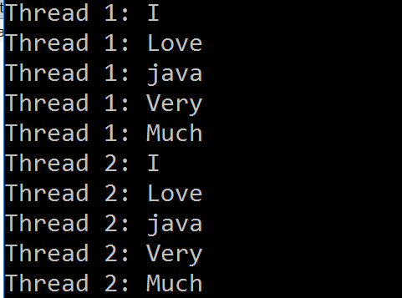

Lab 9- Course Contents: – Java Database Connectivity (JDBC)

- Aim of the program: Write a java program which will display all the records from the student table.

Input: Table name to be mentioned in the program
Output: List of all records from the user supplied table.

- Aim of the program: Write a java program which will display a particular record from the student table on the basis of Rollno supplied from the keyboard.

Input : Rollno (2205542)
Output: List the relevant record from the student table.

- Aim of the program: Write a java program which will insert a record, update and delete a particular record in the student table.

Input: Enter rollno to be inserted: 2205650
Enter name : Aditya Bajaj
Enter marks : 93
Output: 1 record inserted

In the similar fashion, update and delete operations to be performed for the respective input.

- Aim of the program: Write a java program which will display all the records from the student table along with the column heading.

Input: Table name mentioned in the program
Output:
Roll no | Name | Marks
2205123 | rakesh yadav | 76
2205230 | sanjiv kumar | 82
2206345 | pranab dutta | 73
2206242 | asish mukherjee | 78
2205542 | suman singh | 85

Lab 10 - Course Contents: – GUI Programming using Swing in Java
– Event Handling in Java
- Aim of the program -Design a registration form using Swing with following components on it – Label, Textbox, Text area, Checkbox, Radio button and Button, Image.

- Aim of the program -Write a GUI program in Java with three Labels – Enter the First Number, Enter the Second Number, Result, and three text fields for - first number, second number and result and four buttons - Add, Sub, multiply and reset as shown below. On clicking of any of these buttons, the corresponding operation should be performed with input1 and input2 and the result should be displayed in the result box.

Input: First and second number
Output: Appropriate result will be displayed in the result text field

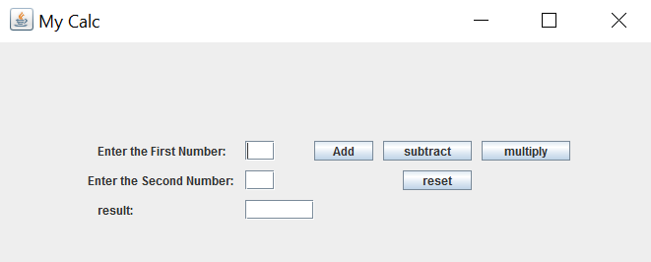

- Aim of the program -Implement a GUI application which consists of one List Box and one button. The list box will have four different color names. When the user will select a color from the list box and click on the button, the panel color will be changed to that color.

Input: Select any color from the list box
Output: Panel background color will be changed accordingly

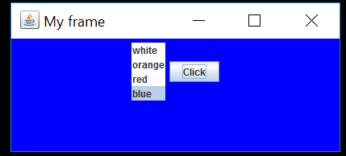

- Aim of the program -Design a GUI application which consists of three Label named as Red, Green and blue, three combo boxes which will consist the value from 0 to 255 and one button named as show output. The user will select different values from three combo boxes. When the user clicks on the button, the panel background will be changed accordingly as per the value passed in RGB format.

Input: select three color value (0-255) from 3 different combo box.
Output: The panel color will be changed accordingly

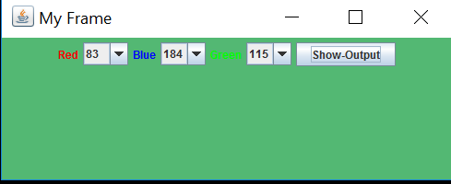
Practice Program Sets:-
- Aim of the program -Design a GUI Calculator as shown below using frame and action event in Java.

Input: Any two number with one operator and then click on = button.
Output: Appropriate result will be displayed.
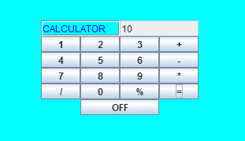
- Aim of the program -Design a GUI application as shown below which consists of two text fields and various buttons for String operations. On clicking any of the buttons, the corresponding operation will be performed on the entered string in the first text field and the resultant string will be displayed in the second text field.
Input: Any string in the first text field and click on any button.
Output: Modified string in the second field

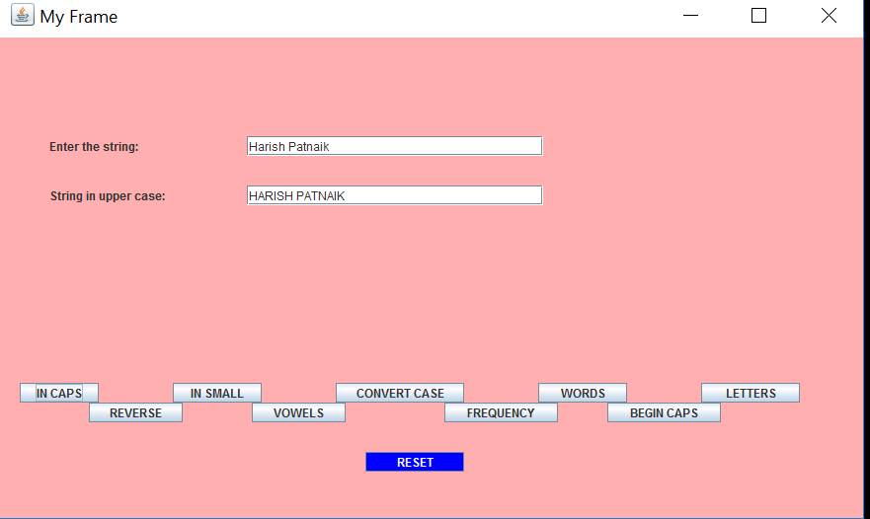

Grading Policies:
- Continuous Evaluation components
Internal Evaluation (Continuous Evaluation over the semester which includes
Quiz/Viva/Lab Record/Lab performance/Attendance etc.) : 60 Marks

- End semester evaluation
End-Term Evaluation (Sessional Exam) : 40 Marks

Reference Materials:-
Reference Book:
- Java-The Complete Reference, Herbert Schildt, 10th Edition, McGraw Hill Education, 2014
- Introduction to JAVA Programming, Y.Daniel Liang, 10th Edition,Pearson Education, 2007
- Java Programming – for Core and Advanced Users, Sagayaraj, Denis, Karthik and Gajalakshmi, Universities Press.
- Java - One Step Ahead, by Anita Seth and B L Juneja, published by Oxford University Press

